PROBLEM SET ON SYNTACTIC PARSING

P1. Given the following grammar
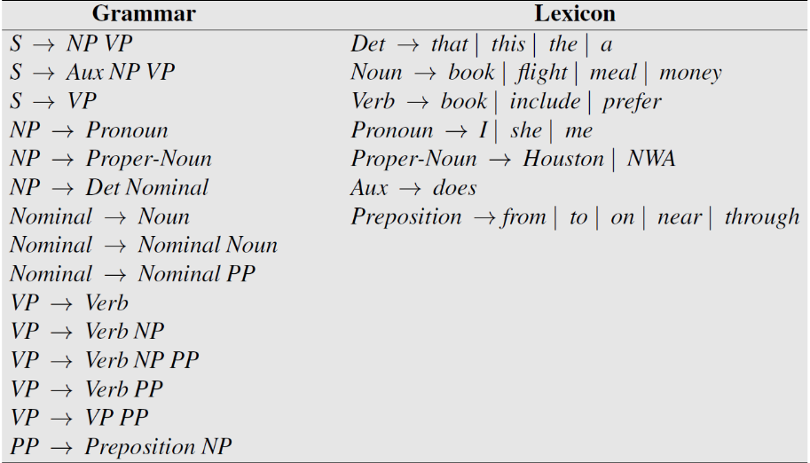
Convert the grammar into Chomsky Normal Form
P2. Given the following grammar
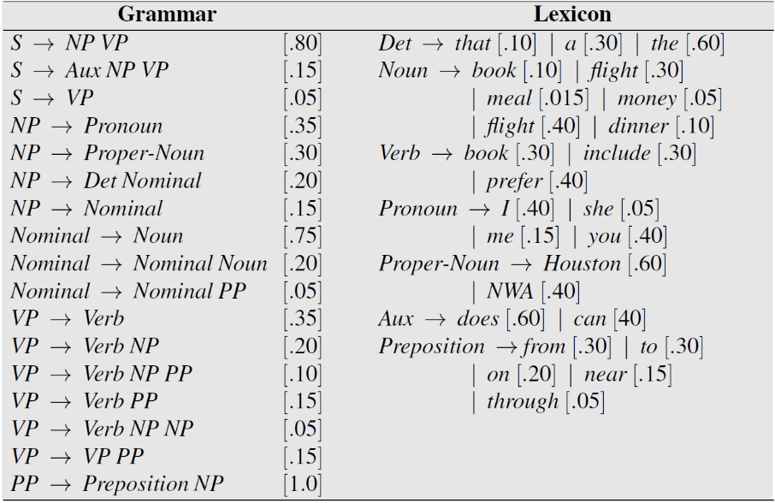
Calculate probability of the following trees
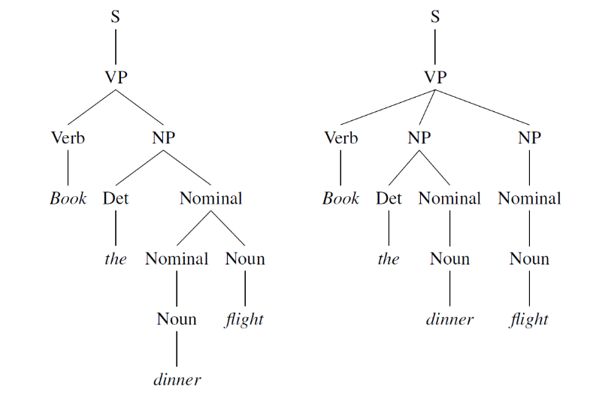
P3. Given the following grammar
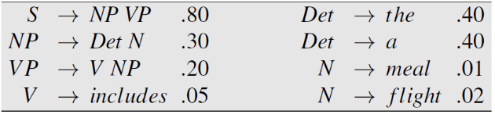
Fill out the rest of the probabilistic CKY chart:
